Karat Batch
Karat Batch Movement to Refinery
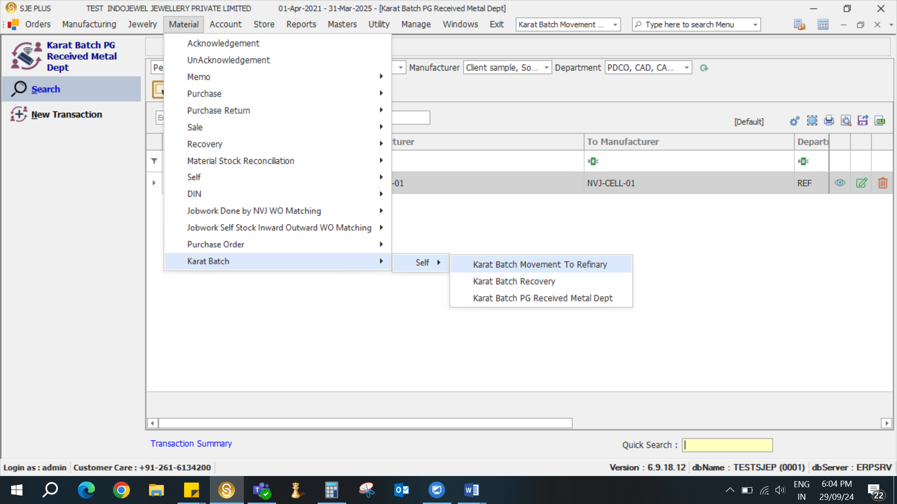
- Select Manufacture and department then select from stock then select employee then load
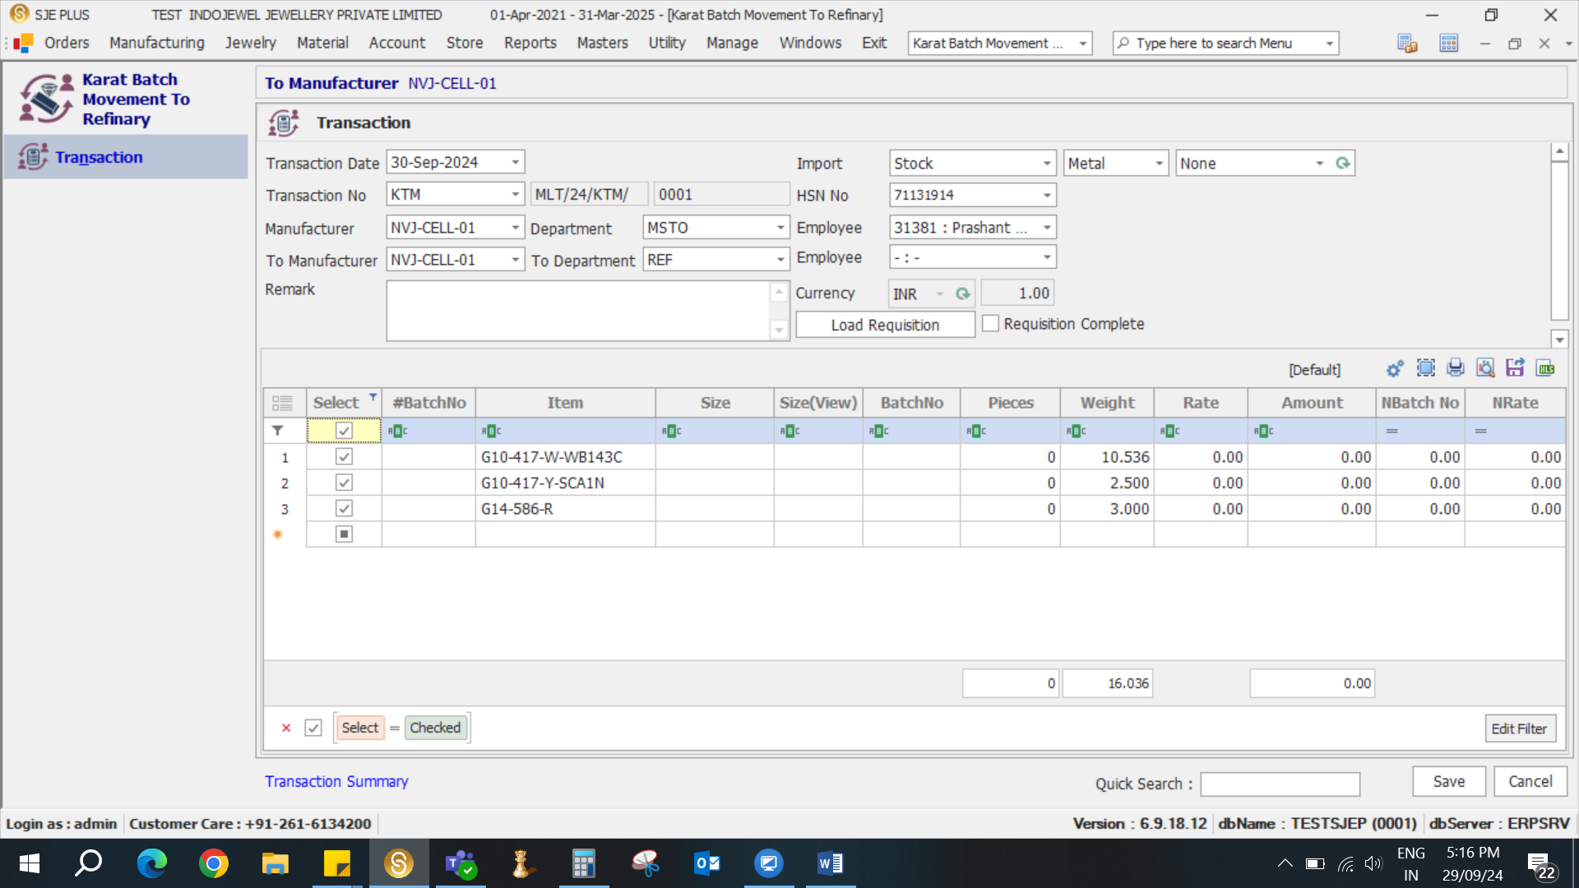
- Select Material enter Weight and save entry.
- Then take to refinery department Acknowledgment select transaction save
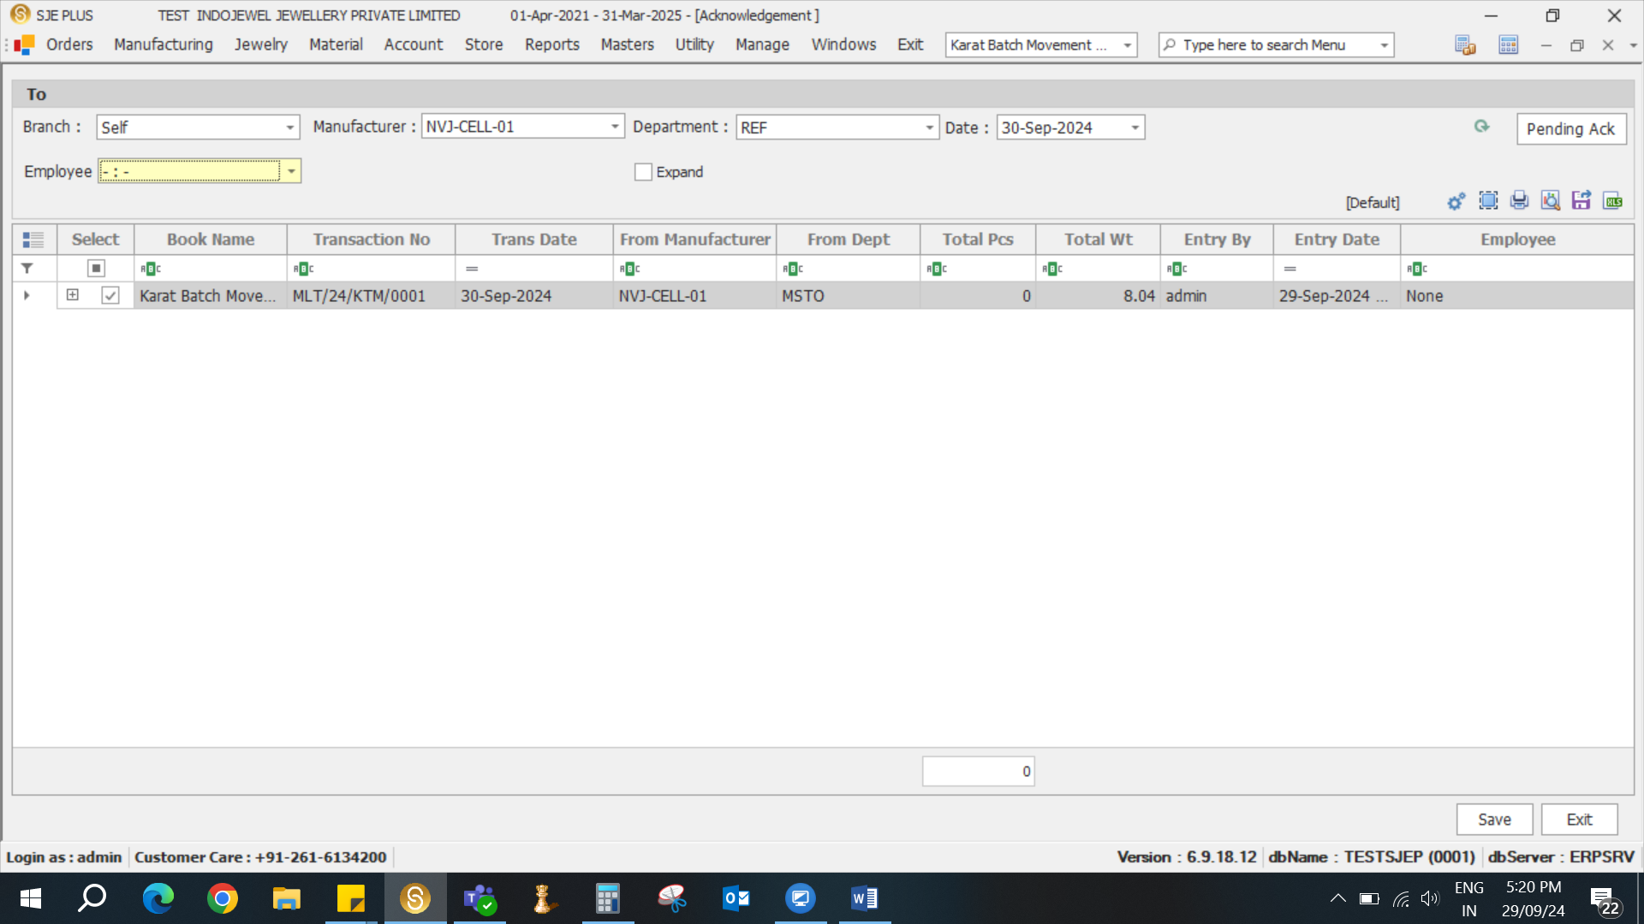
- For conversation to PG
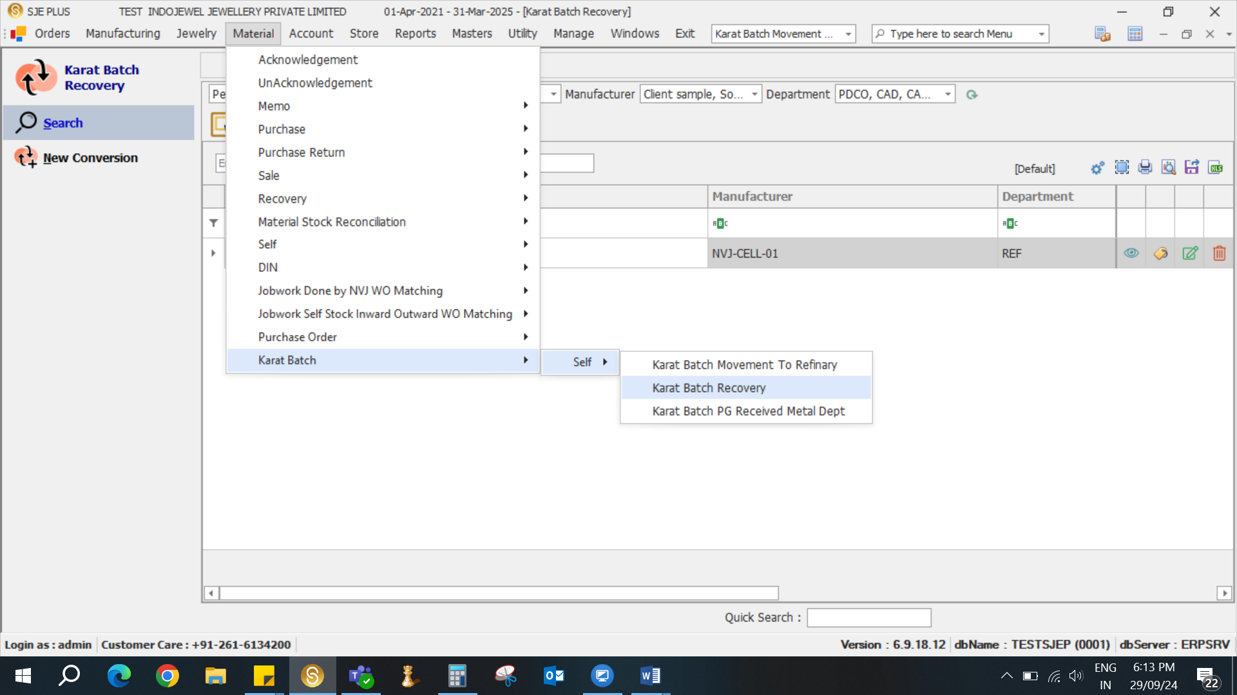

- Select Manufacture and Department.
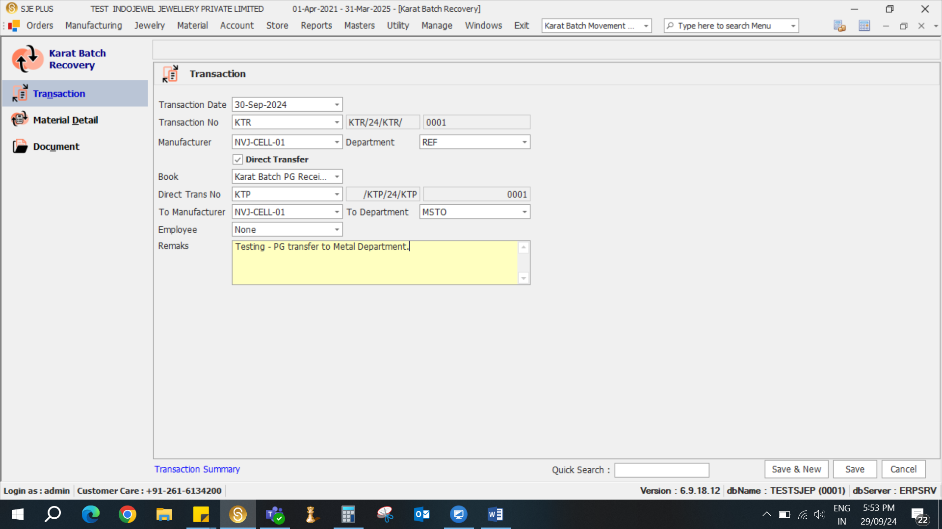
- If You Want to Direct Transfer to PG to Metal Department then select Direct Transfer Option, select Manufacture and department, select employee and enter remark
- Select Material that you want to convert into PG then select PG material and calculate PG weight and enter, then save entry.
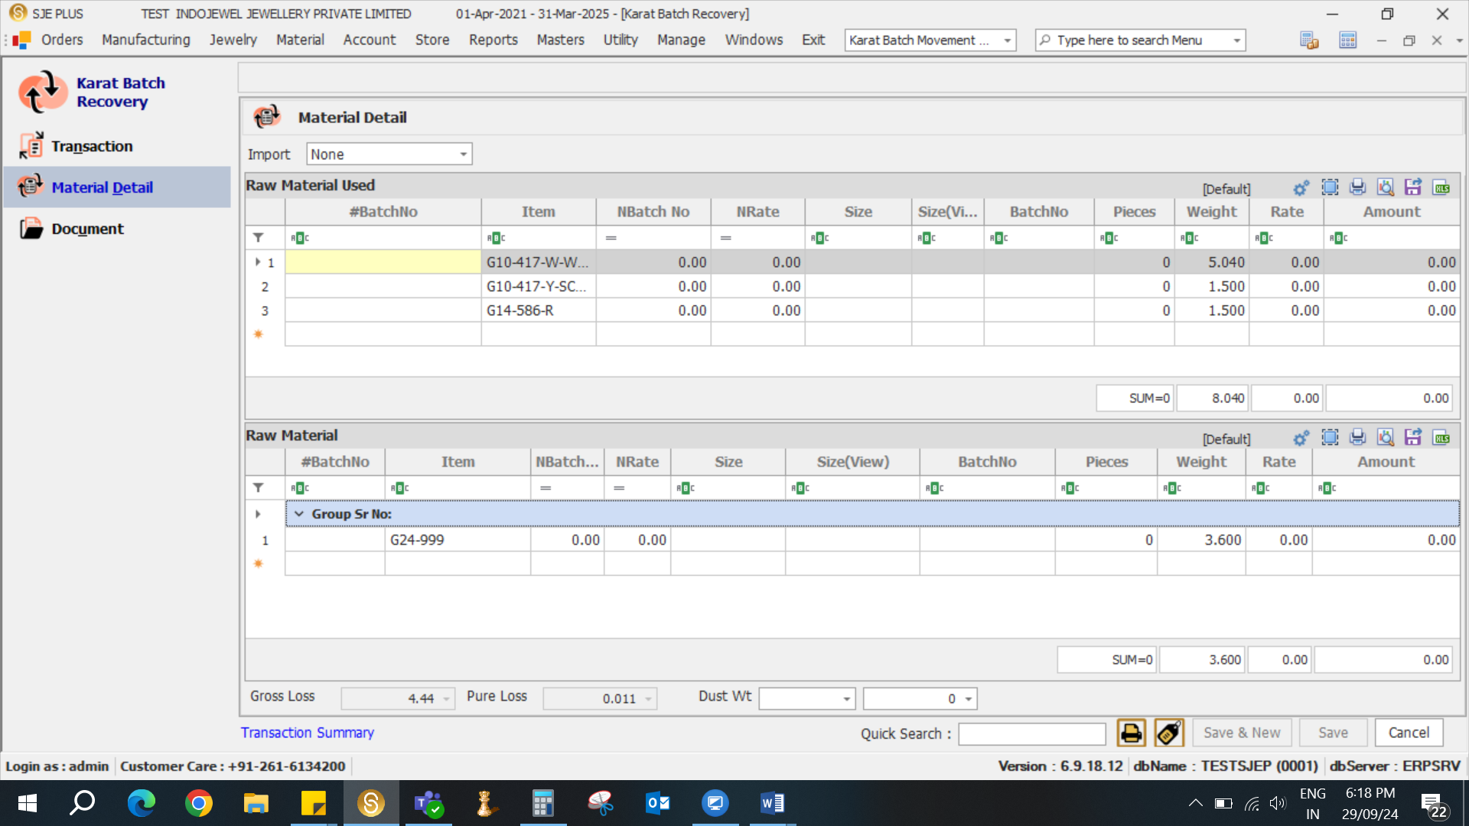
- Transfer to PG to Metal Department.
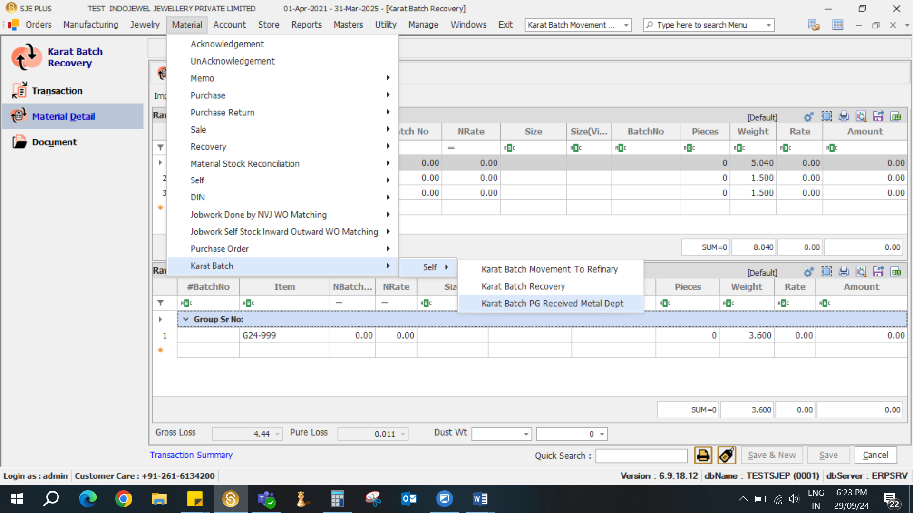

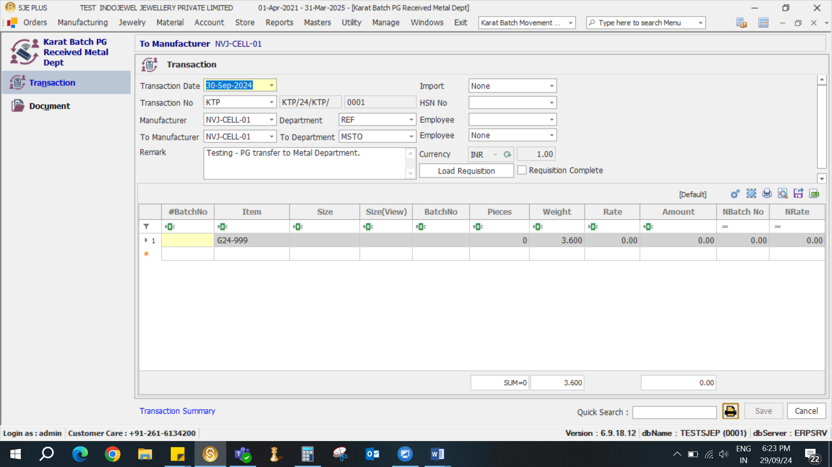

- Material Stock As on report.
